SQL upiti za dashboard

Zadnje stanje svih trafostanica
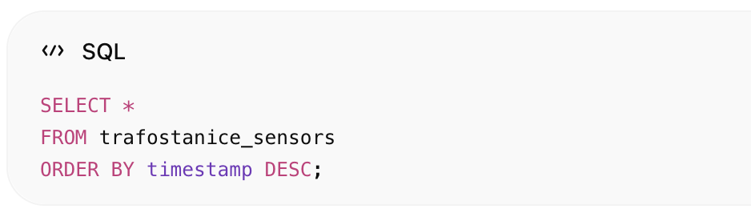
SELECT *
FROM trafostanice_sensors
ORDER BY timestamp DESC;

Alarm visoke temperature
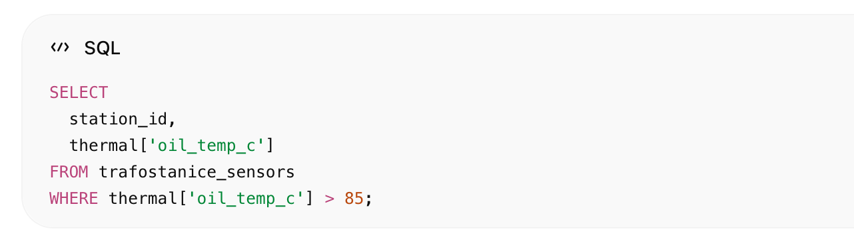
SELECT
station_id,
thermal['oil_temp_c']
FROM trafostanice_sensors
WHERE thermal['oil_temp_c'] > 85;

Geo pretraga
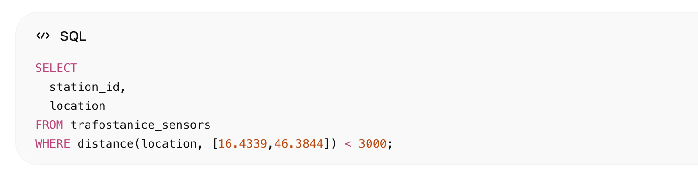
SELECT
station_id,
location
FROM trafostanice_sensors
WHERE distance(location, [16.4339,46.3844]) < 3000;

